Interview with Peter Stenvinkel
Peter Stenvinkel, senior physician and professor, Karolinska Institutet and Karolinska University Hospital.
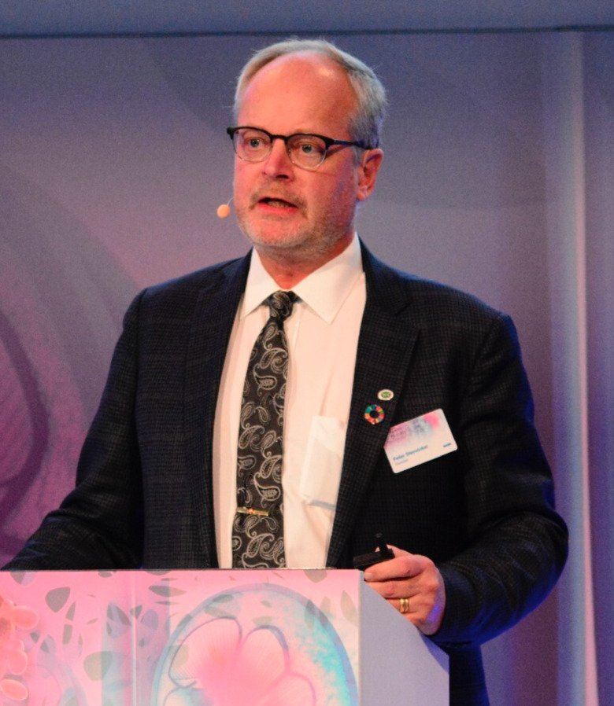
Peter Stenvinkel, professor, Karolinska Institutet. Photo: Private.

Tell us briefly who you are and describe your role and history in the work on sustainable development within healthcare?
I am a senior physician in renal medicine at Karolinska Hospital and professor of nephrology at Karolinska Institutet. For most of my professional years, I have studied inflammation and been interested in how this process, when it becomes chronic, accelerates ageing processes. I have also been interested in biomimetics and how some animals have evolved ingenious mechanisms to protect themselves against ageing, lifestyle diseases and environmental threats. What sparked my interest in planetary health was when I realised that environmental and climate threats seems to stimulate the same systems (inflammation, oxidative stress, senescence, mitochondrial dysfunction and DNA stress) that drive ageing. We now witness how global environmental and climate threats change the disease panorama and increase the risk of accelerated biological ageing leading to chronic lifestyle diseases such as dementia, obesity, type-2 diabetes, pulmonary and cardiovascular disease. This is particularly evident in my own speciality - Nephrology - where an increasing number of publications show how the number of patients with chronic kidney failure is increasing due to a warmer climate and air pollution. In fact, the number of patients with chronic kidney failure may be a ‘barometer of planetary health’. Since planetary health is strongly linked to how we produce and consume food, I have also been interested in how the concept of 'food as medicine' can change our eating habits in such a way that both health, environment and climate are improved - a 'win-win' situation.

What would be the most important message to our staff at NVS about planetary health and sustainable healthcare?
Human activities are wreaking extensive damage on the natural systems of the planet and undermine the prospects for the health of current and future generations on our planet. In recent years, there has been a growing awareness of the stress that climate-related changes have on us. We live in a complex and polarized world and should not forget that while we are living in the 'worst of times' with major environmental and climate threats, we are also living in the 'best of times' where science has made enormous progress.
"We must start to “connect the dots” and understand that human health has always been and will increasingly be related to biodiversity, animal welfare, climate warming, pollution, eating habits etc. Science has shown that what is good for the planet is also good for our health",
The preventive work that decreased the ozone layer can be seen as a positive example of successful global co-operation that benefited the environment. Biodiversity and functioning ecosystems are fundamental for a good planetary health. The Covid-19 pandemic was just a sign of poor planetary health. In our efforts to improve planetary health, we must therefore begin to harness and learn from nature's intelligence. Unlike AI, where we are now beginning to realise that development has been far too rapid, natures intelligence has developed slowly, thoroughly and methodically over million of years. What did not work out during evolution been discarded. Nature is the oldest model, measure, and mentor we could ask for in our search for solutions to the ongoing 6th mass destruction Nature always strives for diversity and it is when diversity is affected, whether in nature, in our arable soils or in the gut bacteria, that problems arise. Biodiversity is needed not only to ensure genetic variation, but also because it is the basis for putting nutritious food on the table and developing new effective medicines.
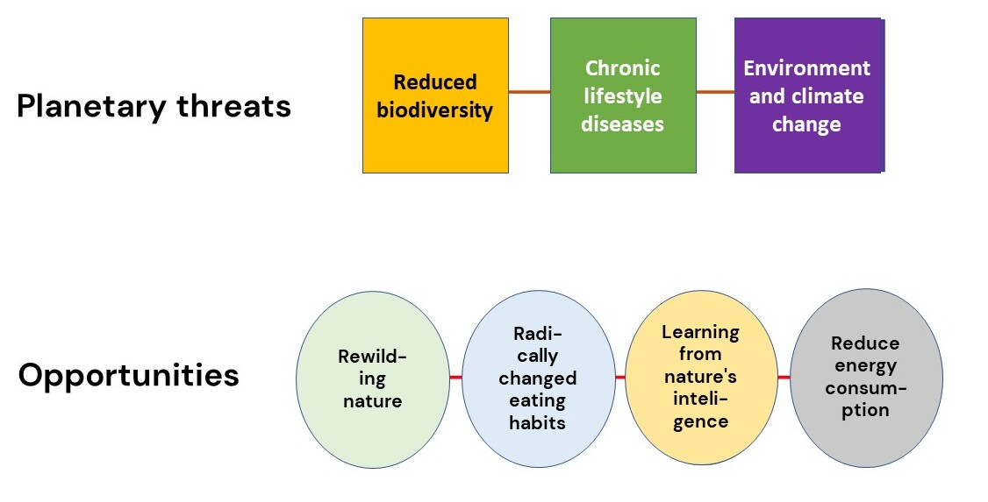
There are now several opportunities to address the major planetary threats. By rewilding nature, radically changing eating habits, learning from nature's intelligence and reducing energy consumption, there are good opportunities to create different 'win'win' situations. Photo: Peter Stenvinkel.
A centre for "Planetary Health" based on interdisciplinary collaboration between different disciplines such as climate scientists, doctors, engineers, veterinarians, physicists, nutritionists, botanists, ecologists, biologists and others offers an opportunity to study in an integrated way the complex relationships and underlying causes that mean that human and planetary health is now threatened by environmental degradation and loss of biodiversity. We need to understand and protect the links between human and animal health and nature's vital ecosystems.

What advice would you like to give to our staff at NVS who want to start contributing to changing education and research based on sustainable development?
Modern food production led to an increase in the consumption of food with large industrial processing such as processed meat, fast-food, canned products and others known as ultra-processed food. Transformation of our eating pattern gives us a golden opportunity to influence both our health and the environment – a ‘win-win’ situation. The EAT-Lancet Commission report shows that a change in eating habits should be based on more locally produced plant-based food with more legumes, fruits, vegetables, nuts and seeds. A limited intake of ultra-processed foods and red meat and more plant-based diets could not only reduce the risk of premature ageing and lifestyle diseases, reduce greenhouse gas emissions and water consumption, but also likely increase our resilience to the harmful effects of a changing environment on our health. A radical transformation of food systems is thus required to enable a healthy population to live on a healthy planet. A key to success in the sustainable management of waste such as dirty water and rubbish is to start viewing waste as a valuable resource that can be reused and provide economic benefits.
"Humans can no longer simply focus on creating a 'win situation’ for their activities. Everything we do and plan for in the future must create a 'win-win situation', i.e. any activity must also at the same time benefit the environment and climate."
Cross-sectoral research actions are thus needed to 'connect the dots' and see the links between the important findings now being made in different research areas. We must stop working according to the current Anthropocene organisational model and instead use nature's intelligence and work according to a biomimetic organisational model. There are reasons for hope despite a long series of grim UN reports. Every dimension of human activity is rich with solutions that can help bring humanity back into balance with our natural systems. The enormous diversity of species, one of the most striking aspects of life on our planet, provides a source of solutions that have been developed through evolution by natural selection in animals living in extreme environments.
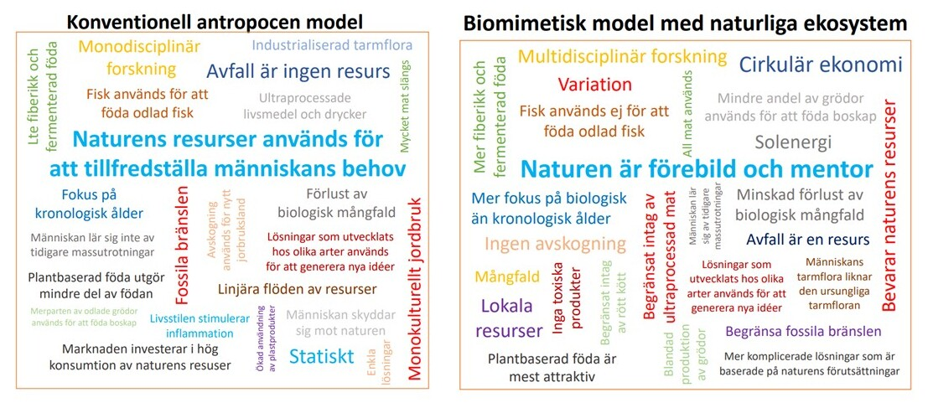
Photo: Peter Stenvinkel.

